**Install School Star and use OutReach+ as a parent - helpcard**

**Introduction**

School Star is an application (app) that can be used by parents to receive messages and news from the school, reply to messages the school has sent and send messages to the school.

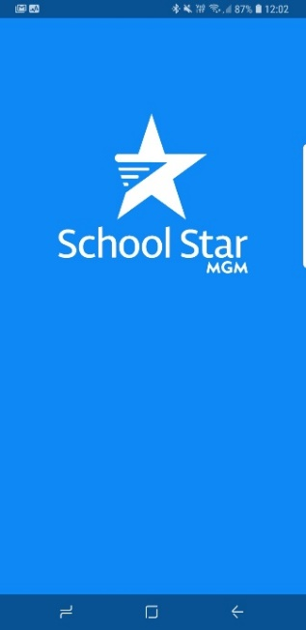**Note**: The following screenshots have deliberately been taken on a number of different mobile phones so there may be slight differences in what is included here and what you may see on various devices.

**Step 1 - Install School Star**

* School Star is available in the Google Play Store® and Apple App Store® by searching for “School Star”.
* 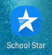The app icon looks like this.
* Once the app is installed you must be registered by the contact details and school may have for you.

**Step 2 – Open the app.**

While loading, the screen will appear as shown below.

* Once loaded, the initial screen will appear.



**Step 3 – Register**

* Click on Register.



* Enter your own mobile number without the first zero then click Continue. This will find any school that your mobile number is associated with as a parent eg if you have a child in primary and a child in a secondary school, you will see both schools.

**EXAMPLE**

0493 617 704

is entered as

493 617 704

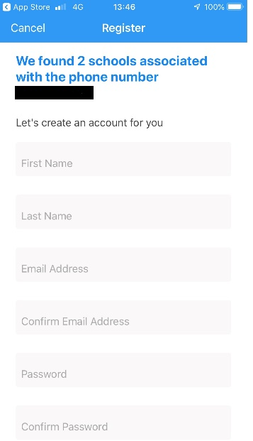**Step 4 – Create an account**

* Complete all required information.

School Star may identify that you are registered in more than one school as shown.

* This means you can connect and engage with multiple schools using the one app.
* You must use the email address you have given the school ie if you have several email addresses, the right one needs to be entered.
* At the bottom of the screen click on Create Account.

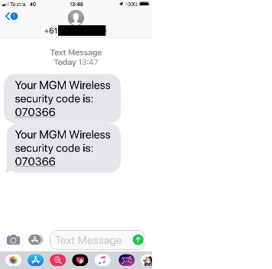

* You will receive a txt message with a single use Security Code.



123456

* Enter the Security Code in your phone in the screen shown eg 123456.
* If you do not receive the Security Code in a short period of time, click on the “Tap here to resend” link.



* Once the Security Code has been confirmed, a “Successfully Verified” screen will appear. Click on Finish.

SCHOOL NAME APPEARS HERE

**Note:** You need to verify your email address to give full access to School Star functionality.

If you log out of School Star you will need to log in again and enter your email address and password.

**Make sure it’s the correct email address you have registered with the school your child attends.**

* You will also receive an email to verify your email address. If you do not receive the email check your Junk Email folder. Drag it to your Inbox and it will appear as shown.

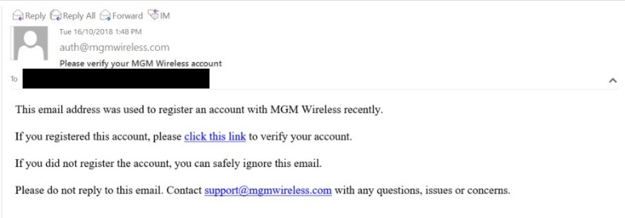

* Click on “click this link” to verify your account.
* This will open a web browser that will show the following.



**Step 5 – Access and use School Star**

* The front screen (News page) of School Star will appear as shown.
* To manage incoming and outgoing messages. 

